Student Deliverables
01/29/2026
Outputs after running 1C_Bonus_B -> Terraform Apply
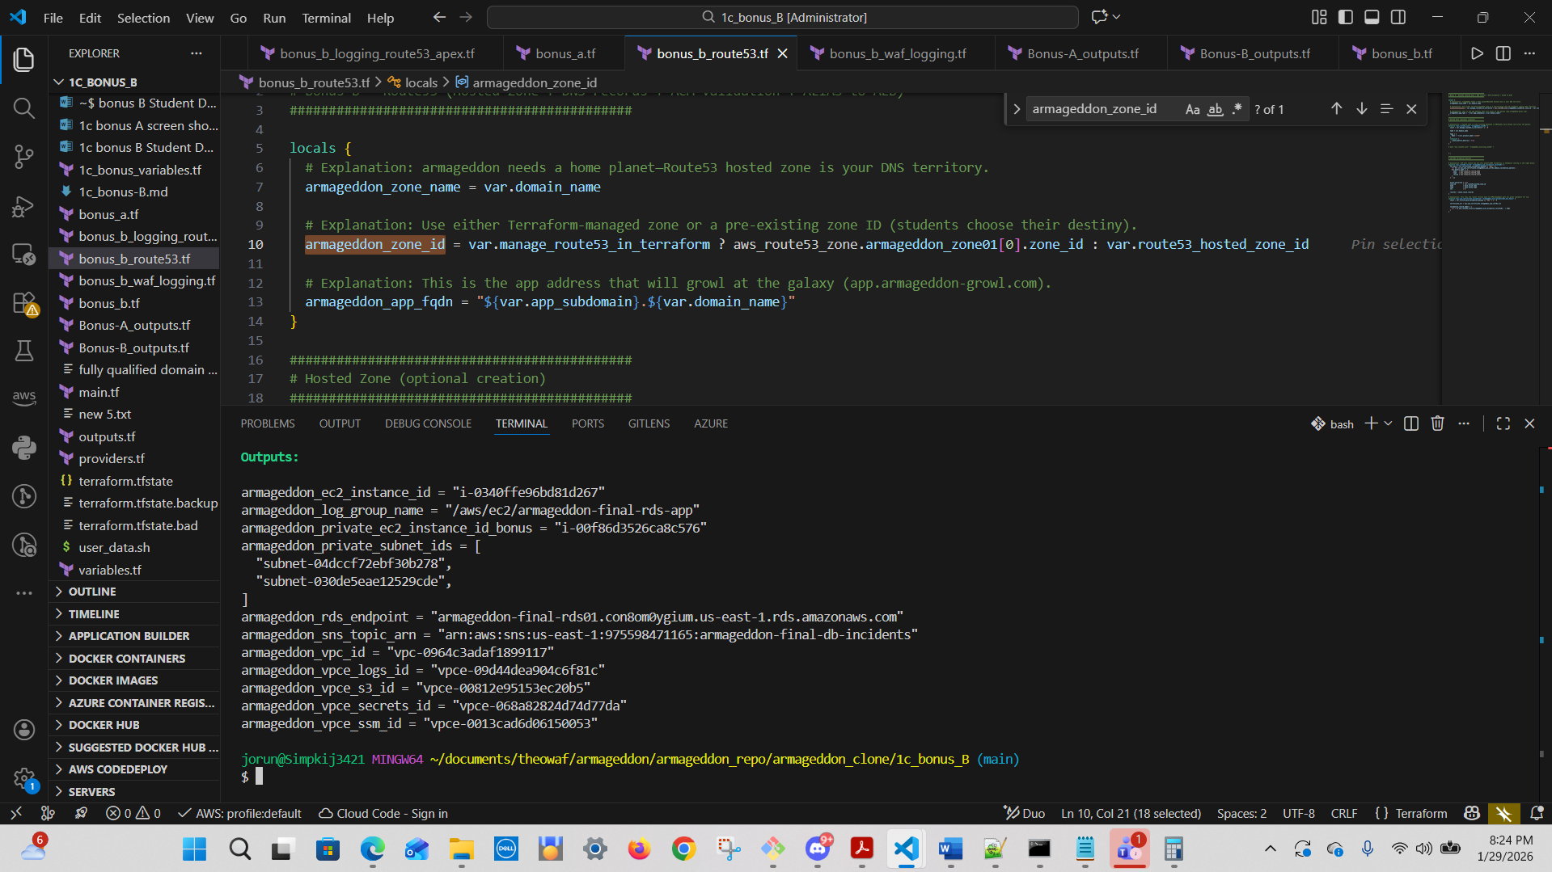
Notes:
What you must implement (so you learn the right pain)
TLS (ACM) validation for app.chewbacca-growl.com

You gave them the domain; they must complete one of:
#NOTE: DNS validation was chosen instead of e-mail.
DNS validation (best): create Route53 hosted zone + validation records in Terraform
Email validation (acceptable): do it manually, then Terraform continues (less ideal)

Suggested student path (DNS):
Create Route53 Hosted Zone for chewbacca-growl.com
Add aws_route53_record for ACM validation
Add a CNAME (or ALIAS) pointing app.chewbacca-growl.com → ALB DNS

I didn’t auto-add Route53 resources because some students may manage DNS outside Route53.
But if you want, I can provide a Route53 skeleton too (Hosted Zone + records + ACM validation),
Chewbacca-style.

ALB SG rules
you must add:
inbound 80/443 from 0.0.0.0/0
outbound to targets on app port

EC2 runs app on the target port
They must ensure their user-data/app listens on port 80 (or update TG/SG accordingly).

Verification commands (CLI) for Bonus-B
1) ALB exists and is active

aws elbv2 describe-load-balancers \
--names “armageddon-final-alb01” \
--query "LoadBalancers[0].State.Code"

Output:

jorun@Simpkij3421 MINGW64 ~/documents/theowaf/armageddon/armageddon_repo/armageddon_clone/1c_bonus_B (main)
$ aws elbv2 describe-load-balancers \
--names armageddon-final-alb01 \
--query "LoadBalancers[0].State.Code"
"active"
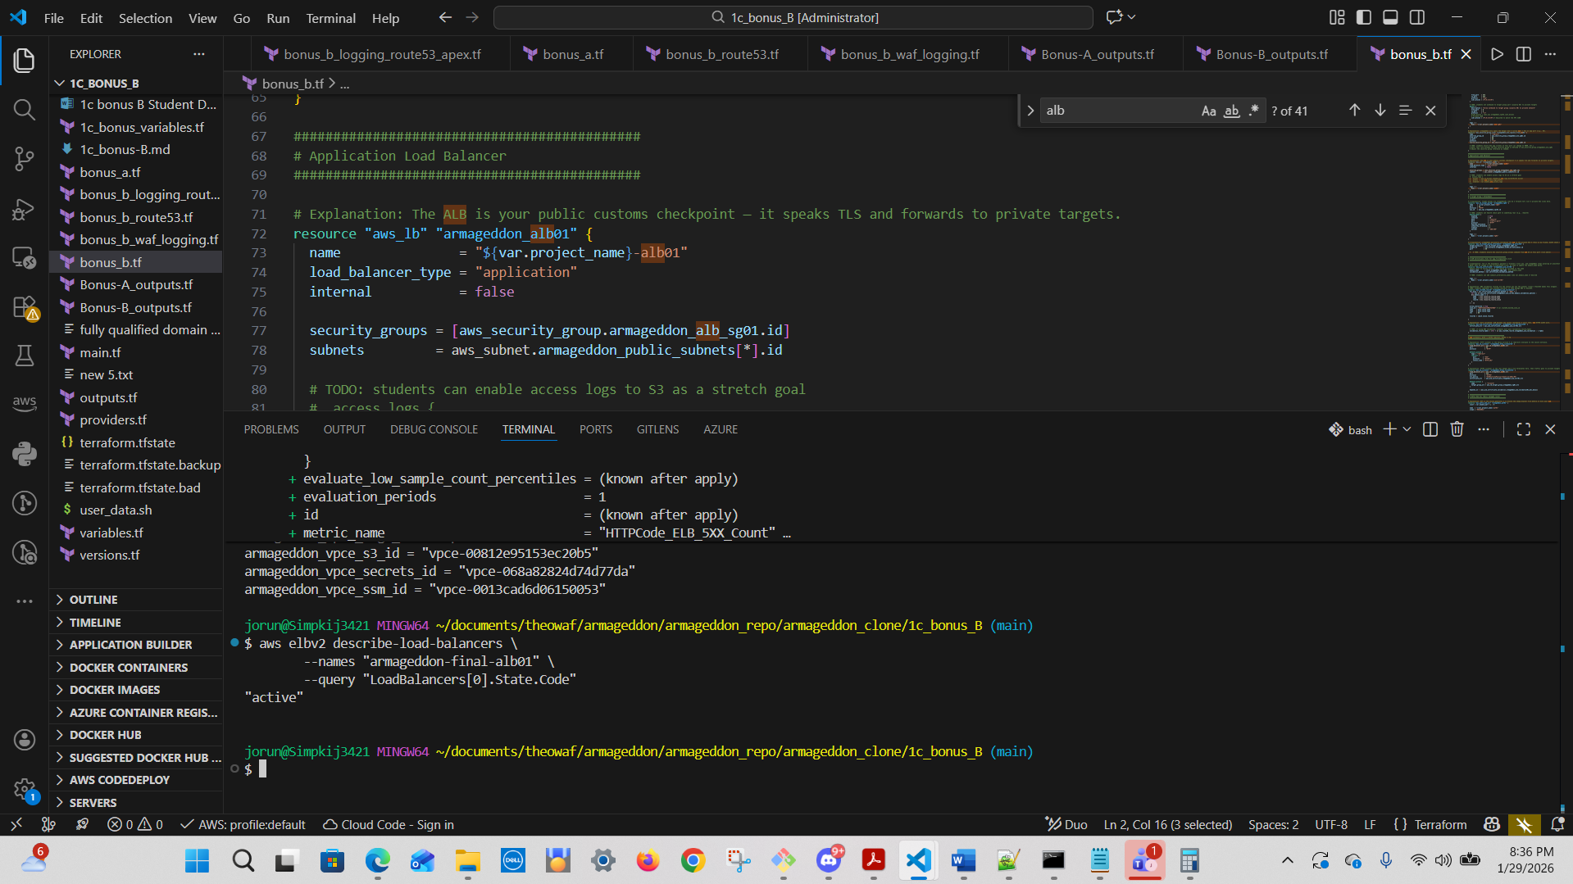

3) HTTPS listener exists on 443

aws elbv2 describe-listeners \
--load-balancer-arn <ALB_ARN> \
--query "Listeners[].Port"
ALB – Application Load Balancer ARN
arn:aws:elasticloadbalancing:us-east-1:975598471165:loadbalancer/app/armageddon-final-alb01/13aa3ba907cddb72

Listner ARN:
arn:aws:elasticloadbalancing:us-east-1:975598471165:listener/app/armageddon-final-alb01/13aa3ba907cddb72/7af0ae0404692a00

Input @ CLI:
aws elbv2 describe-listeners \
--load-balancer-arn arn:aws:elasticloadbalancing:us-east-1:975598471165:loadbalancer/app/armageddon-final-alb01/13aa3ba907cddb72 \
--query "Listeners[].Port"
Output:
jorun@Simpkij3421 MINGW64 ~/documents/theowaf/armageddon/armageddon_repo/armageddon_clone/1c_bonus_B (main)
$ aws elbv2 describe-listeners \
--load-balancer-arn arn:aws:elasticloadbalancing:us-east-1:975598471165:loadbalancer/app/armageddon-final-alb01/13aa3ba907cddb72 \
--query "Listeners[].Port"
[
80,
443
]

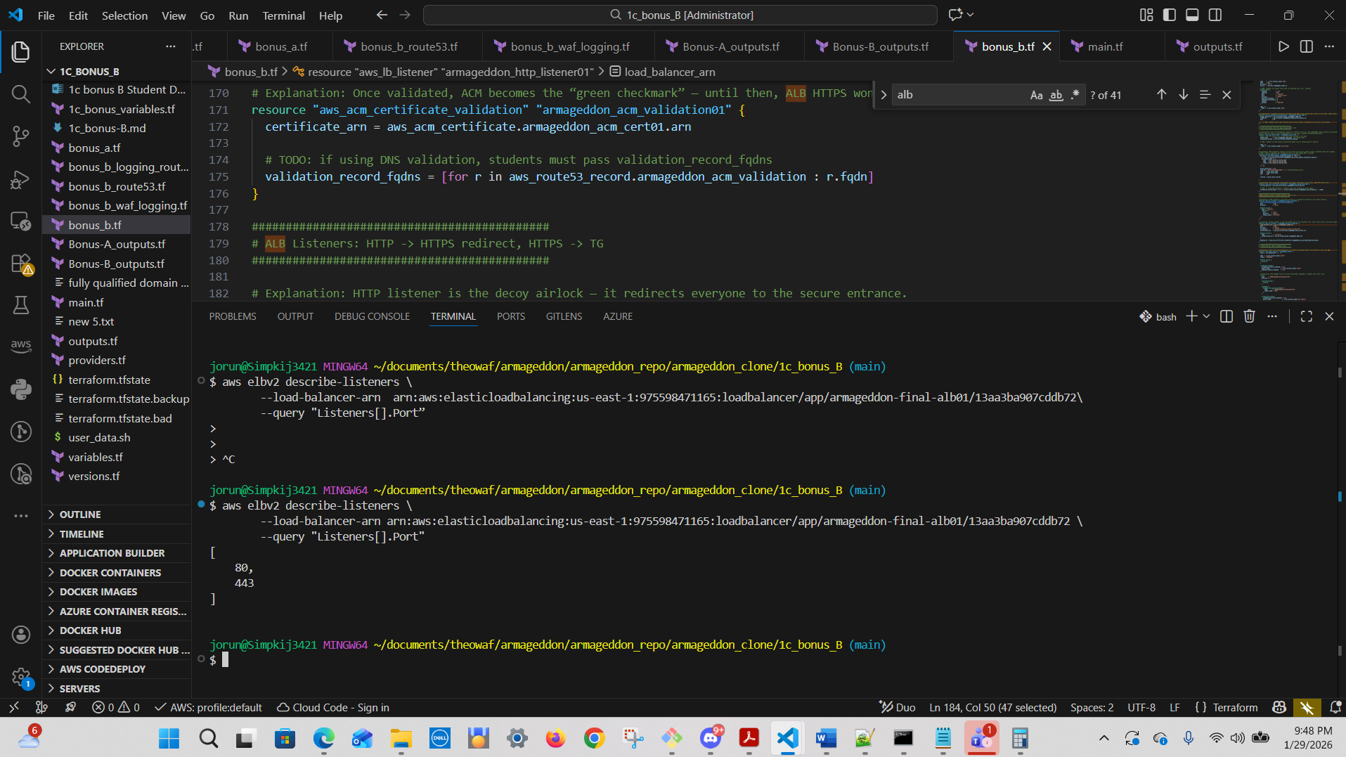

4) Target is healthy

aws elbv2 describe-target-health \
--target-group-arn <TG_ARN>
arn:aws:elasticloadbalancing:us-east-1:975598471165:targetgroup/armageddon-final-tg01/2acd735f7b2f796c
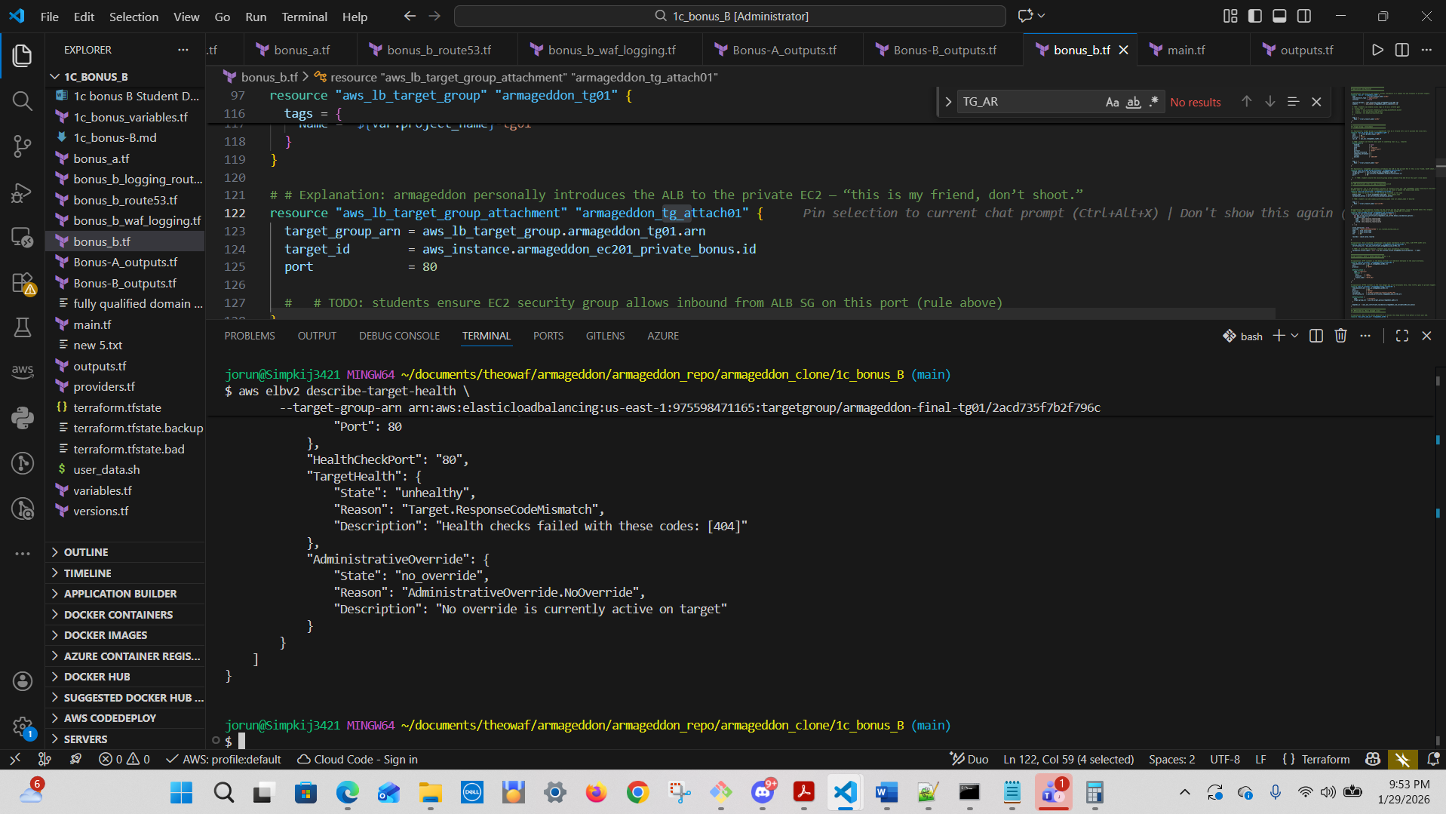

5) WAF attached

aws wafv2 get-web-acl-for-resource \
--resource-arn arn:aws:elasticloadbalancing:us-east-1:975598471165:loadbalancer/app/armageddon-final-alb01/13aa3ba907cddb72
ALB_ARN:
arn:aws:elasticloadbalancing:us-east-1:975598471165:loadbalancer/app/armageddon-final-alb01/13aa3ba907cddb72

Output:
jorun@Simpkij3421 MINGW64 ~/documents/theowaf/armageddon/armageddon_repo/armageddon_clone/1c_bonus_B (main)
$ aws wafv2 get-web-acl-for-resource \
--resource-arn arn:aws:elasticloadbalancing:us-east-1:975598471165:loadbalancer/app/armageddon-final-alb01/13aa3ba907cddb72
{
"WebACL": {
"Name": "armageddon-final-waf01",
"Id": "7d7e422f-5453-4e82-a30d-1ae26b94af1c",
"ARN": "arn:aws:wafv2:us-east-1:975598471165:regional/webacl/armageddon-final-waf01/7d7e422f-5453-4e82-a30d-1ae26b94af1c",
"DefaultAction": {
"Allow": {}
},
"Description": "",
"Rules": [
{
"Name": "AWSManagedRulesCommonRuleSet",
"Priority": 1,
"Statement": {
"ManagedRuleGroupStatement": {
"VendorName": "AWS",
"Name": "AWSManagedRulesCommonRuleSet"
}
},
"OverrideAction": {
"None": {}
},
"VisibilityConfig": {
"SampledRequestsEnabled": true,
"CloudWatchMetricsEnabled": true,
"MetricName": "armageddon-final-waf-common"
}
}
],
"VisibilityConfig": {
"SampledRequestsEnabled": true,
-- More --
"Name": "AWSManagedRulesCommonRuleSet"
}
},
"OverrideAction": {
"None": {}
},
"VisibilityConfig": {
"SampledRequestsEnabled": true,
"CloudWatchMetricsEnabled": true,
"MetricName": "armageddon-final-waf-common"
}
}
],
"VisibilityConfig": {
"SampledRequestsEnabled": true,
"CloudWatchMetricsEnabled": true,
"MetricName": "armageddon-final-waf01"
},
"Capacity": 700,
"ManagedByFirewallManager": false,
"LabelNamespace": "awswaf:975598471165:webacl:armageddon-final-waf01:",
"RetrofittedByFirewallManager": false,
"OnSourceDDoSProtectionConfig": {
"ALBLowReputationMode": "ACTIVE_UNDER_DDOS"
}
}
}

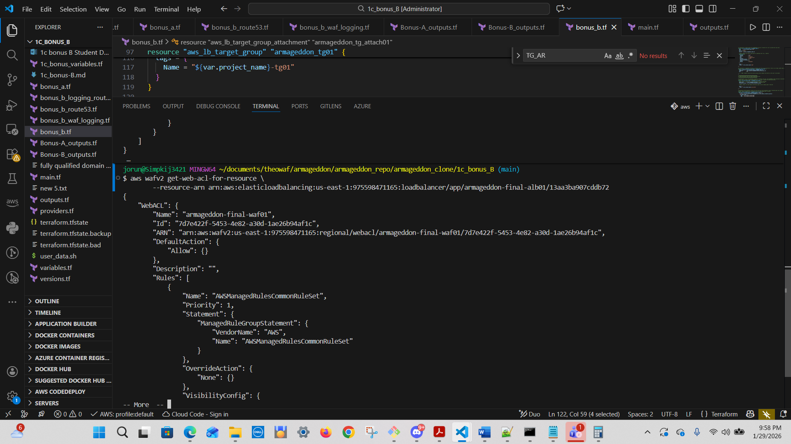
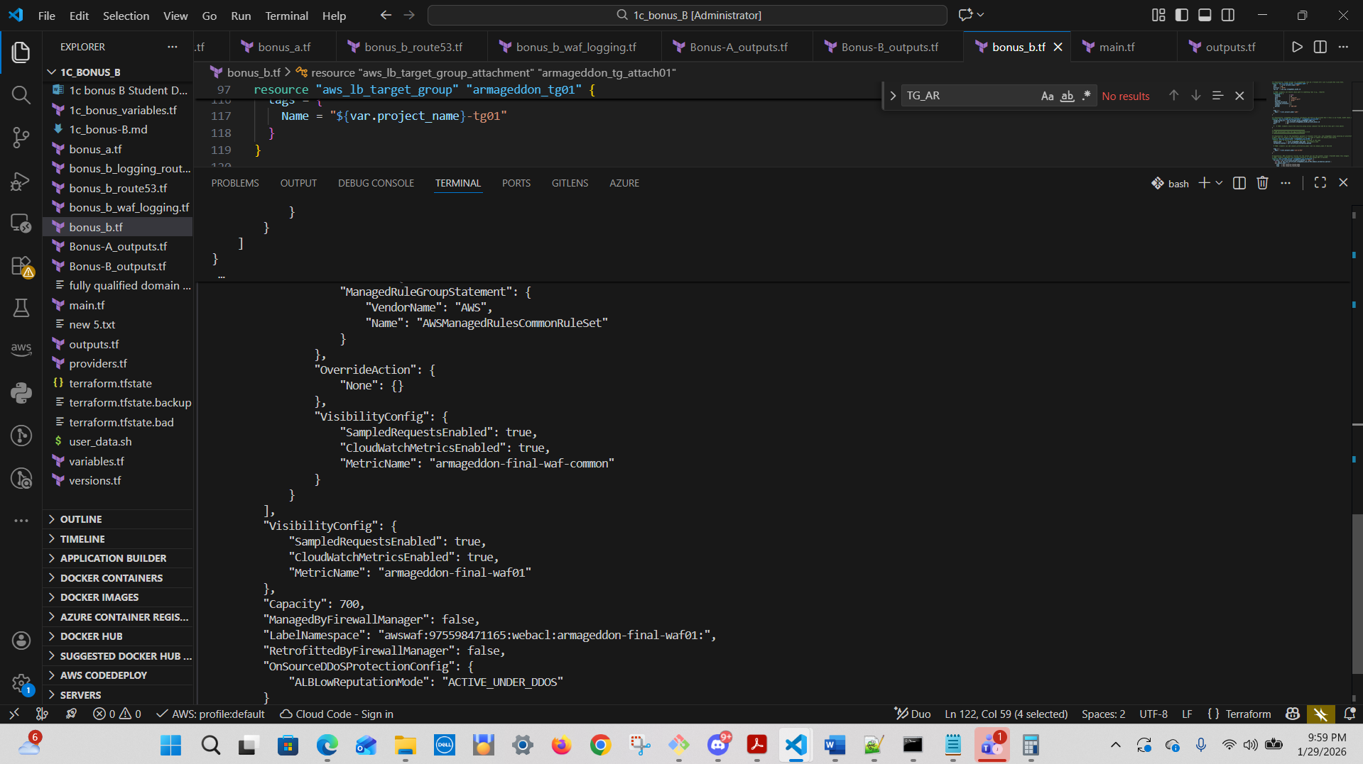
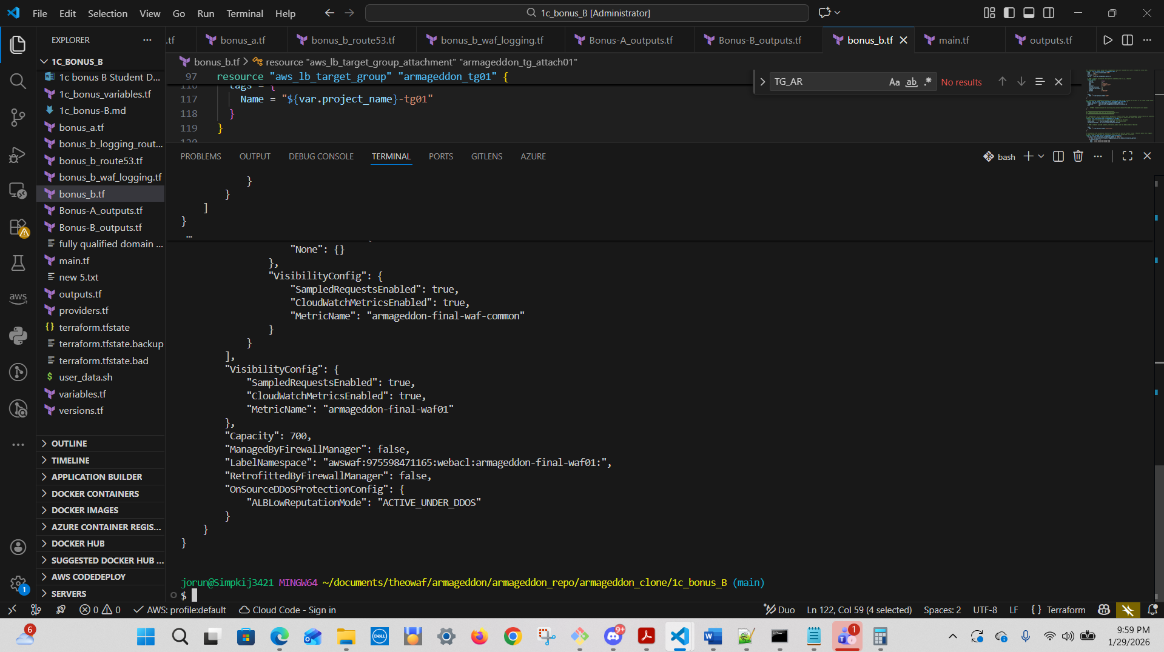

7) Alarm created (ALB 5xx)

aws cloudwatch describe-alarms \
--alarm-name-prefix armageddon-alb-5xx
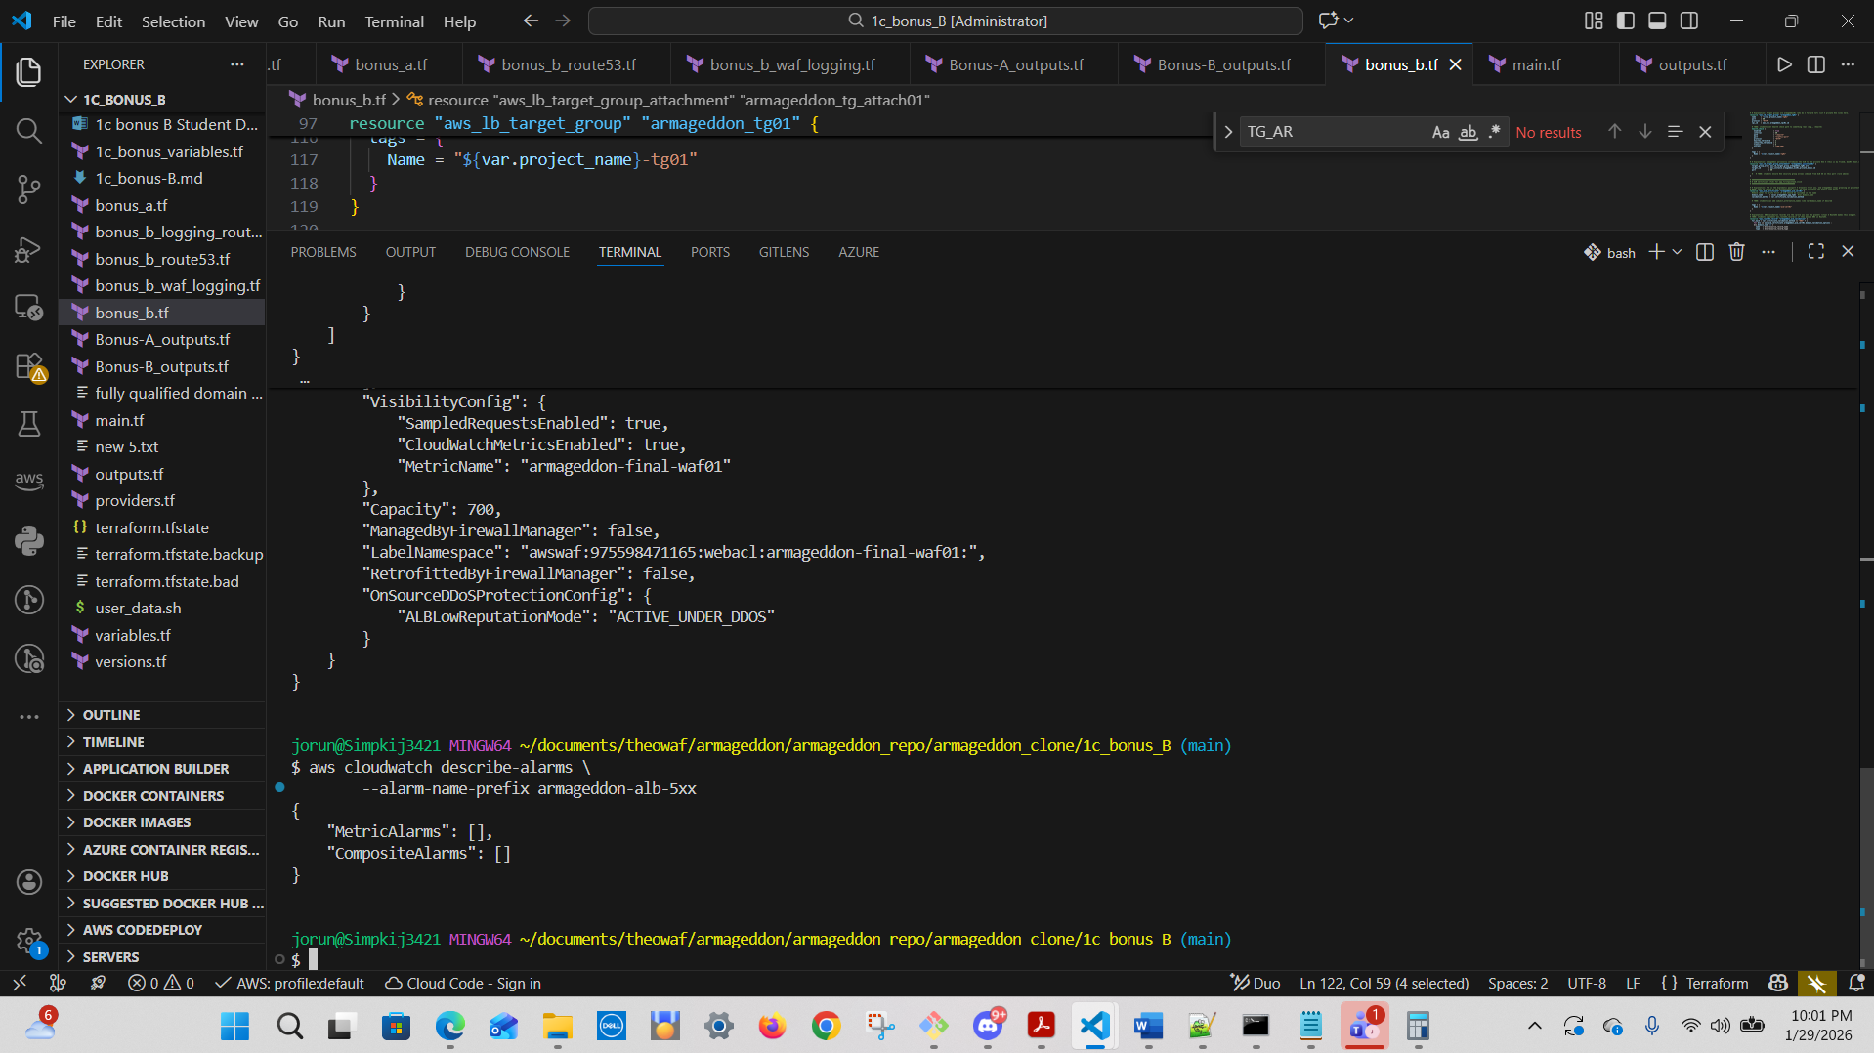

jorun@Simpkij3421 MINGW64 ~/documents/theowaf/armageddon/armageddon_repo/armageddon_clone/1c_bonus_B (main)
$ aws cloudwatch describe-alarms \
--alarm-name-prefix armageddon-alb-5xx
{
"MetricAlarms": [],
"CompositeAlarms": []
}

9) Dashboard exists

aws cloudwatch list-dashboards \
--dashboard-name-prefix Armageddon
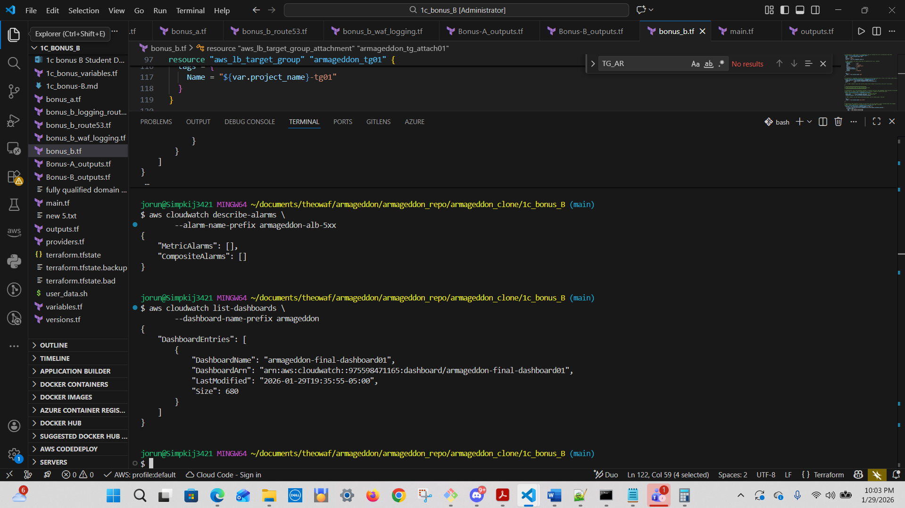

jorun@Simpkij3421 MINGW64 ~/documents/theowaf/armageddon/armageddon_repo/armageddon_clone/1c_bonus_B (main)
$ aws cloudwatch list-dashboards \
--dashboard-name-prefix armageddon
{
"DashboardEntries": [
{
"DashboardName": "armageddon-final-dashboard01",
"DashboardArn": "arn:aws:cloudwatch::975598471165:dashboard/armageddon-final-dashboard01",
"LastModified": "2026-01-29T19:35:55-05:00",
"Size": 680
}
]
}

